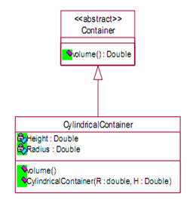

# Question 01

The Volume of a Cylinder can be found with the following formula:

Volume = PI * Radius*Radius*Height where PI=3.14159

It is required to map the above class diagram to Java code.

Note: Container is an abstract class.

Height & Radius are private variables

All the methods are public

1. Write down the Java definition of class container
2. Write the Java Definition of class CylindricalContainer. (Implement the Methods)
3. Create an object from CylindricalContainer and display the volume.

# Question 02

A Student wants to create a game called “Life”, ‘life’ is a RPG game in which a player can move up, down, left & Right. In order to implement this game assume that you need to create an abstraction of the player controllers. Make sure to print the directions of the player when keys are pressed.